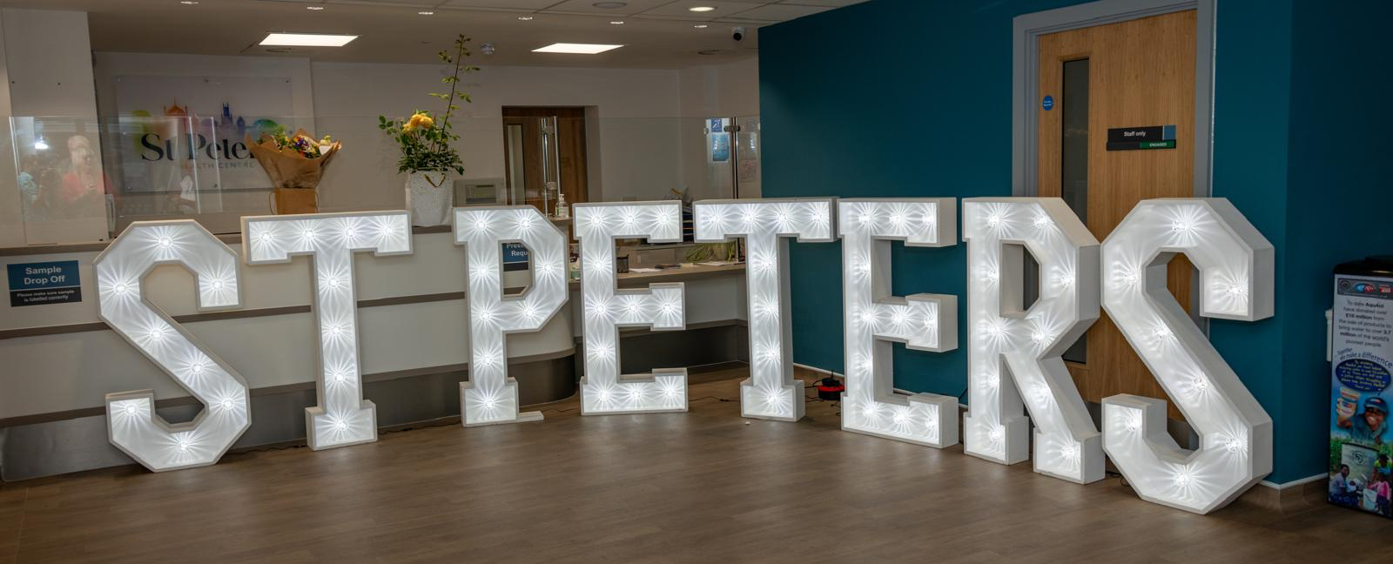
PPG Meeting Agenda
Tuesday 23rd June 2026
6-7.30pm

- Welcome and introductions (Joanne)
  - Purpose and scope of PPG
  - Agree revised roles
  - PPG active committee members /volunteers

- Agree the minutes from 25th February meeting (Joanne)

- Matters Arising/Actions (Joanne & St Peter’s staff)
  - PPG grant application
  - Pharmacy First session
  - Healthy Hearts Event

- St Peter’s update (Dr Jarvis)

- PPG Updates (Joanne)
  - Update from Sussex PPG Network – Robert?
  - Menopause Café – Joanne
  - Communication System
  - Wider staff involvement/support

- Discussion Focus:
- Future Health Education Events
- Widening Community Engagement

- AOB (Joanne)
  - Date of next Public Meeting – Oct tbc

